Talbot Green Group Practice

Welcome to Talbot Green Group Practice.
Thank you for choosing us to be your doctors.
We hope you find this leaflet useful.

We work from two sites:
Newpark Surgery |  | Gwaunmiskin Road Surgery
Heol y Gyfraith  Talbot Green  Pontyclun  CF72 8AJ   01443 220320 |  | 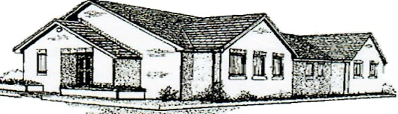  Gwaunmiskin Rd  Beddau  Pontypridd  CF38 2AU   01443 219810
Opening times:
Monday – Friday:  8.00am – 6.30pm |  | Monday & Wednesday:  8.30am – 6.00pm  Tuesday, Thursday, Friday:  8.30am - 12.30pm
If a doctor is needed outside these hours, please contact:
 111
We have a lot of useful information on our website:
www.talbotgreengrouppractice.co.uk
(Including online access to prescriptions, appointments, and some electronic consultation requests)

Our team:
Doctors |  | Practice manager  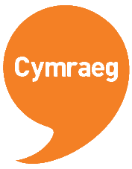  Mr John Rees  Nurses  Nichola Davies - RGN  Nicola Olds-Davies - RN Bachelor Science  Rosa Piccione -RGN  Health Care assistants  Carol Evans  Amanda Anthony
Dr R Parfitt  Dr M Rogers  Dr B Adams  Dr S Foulkes  Dr S Lloyd  Dr S Alfaham  Dr Lee Thomas  Dr C Davies  Dr N King | (Senior partner, male)  (GP partner, male)  (GP partner, male)  GP partner, female)  (GP partner, female)  (GP partner, female)  (GP, Male)  (GP, Female)  (GP Female)
We are fortunate to be a training practice.
You may have a consultation with a qualified doctor who has
extensive hospital experience and is working with us to gain an insight into general practice.

Register To register at the practice, please ask at reception for the forms.

Routine Appointments The practice operates an appointment system during normal surgery hours. You can book an appointment either by telephone or online. Routine appointments can be booked up to two weeks in advance. Patients can request to see the same GP, but you may need to wait longer for an appointment for the GP of your choice. Please remember, appointments are 10 minutes long, and it is unrealistic to manage multiple problems in one appointment. If you have multiple issues to discuss, you may need to book a further review. Please note that if you arrive more than 10 minutes late for an appointment, you will be asked to re-book for another day.

Urgent Appointments If you feel your problem is urgent, and you need to be seen on the same day, please let the receptionist know when you call. Emergency appointments are dealt with each morning, so please phone before 10:30am. The receptionist will ask some basic information about your problem, so the doctor can see the most urgent cases first. You will be given a time to attend the surgery that morning, but please note due to the nature of medical emergencies, you still may have a wait to be seen.

Cancellations If you cannot attend your appointment, please inform us as soon as possible so we can offer it to another patient.

Home Visits are reserved only for permanently housebound patients and are based on clinical need at the discretion of the doctor. If you feel you need a home visit, please contact reception as soon as possible between 8.30 – 10.30. The doctor may telephone you back to obtain more information. We expect children to be brought to the surgery where they can be seen quickly and examined in the most appropriate surroundings. Lack of transport or other inconvenience is not a valid reason for a house call. In such cases, you may be offered a review at the surgery at short notice, if appropriate

e-consultations We offer an online service for some simple problems, medication and sick note requests. This is available through our website www.talbotgreengrouppractice.co.uk. Your request will be responded to within 24hours.

Prescription Requests We regret that we cannot accept prescription requests over the telephone. Please ensure that you mark the items you require clearly by ticking the appropriate medication on the repeat request form, or order online. Please note, we process large number of requests each day, and 48 hours’ notice is needed for repeat requests. Please ensure that prescriptions needed over the weekend are ordered by Wednesday and collected before the surgery closes on Friday evening.
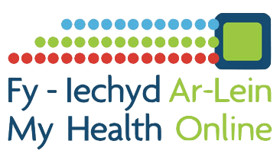
‘My Health Online’ also allows you to pre-book and cancel appointments and request repeat medication.

 | Clinics and Services Available Contraceptive Services, Childhood Immunisations, Childhood Health Surveillance, Vaccinations and Immunisations, Minor Illness, Minor Surgery, INR Warfarin Monitoring, Spirometry, ECG, Phlebotomy, Case Management for Patients with Long-Term Conditions, e.g. Asthma, Diabetes, Hypertension, Epilepsy, Heart Disease And COPD, Ante-Natal Clinic, Practice Counsellor, Cytology (Smear) Clinic, Travel Vaccine Advice).
 | Flu The practice participates in the annual national flu campaign which begins every September. Patients with certain conditions are entitled to the flu vaccine free of charge. Please contact the surgery for further details
Community Nurses (District nurses) work alongside the doctors at this practice.
They can be contacted directly on  01443 444069

 | Travel advice is given by our practice nurses. Please make a 20-minute appointment at least 6 weeks before travelling.
Health visitors see children up to 5 years old at our well-baby, and provide advice on weighing, feeding, injections and many other aspects of a child’s development.
Newpark: Monday 1.30- 2.30pm, Beddau: Wednesday 1.30-3.00pm  01443 449129

 | Midwives care for mothers during pregnancy and for some time after the birth of the baby
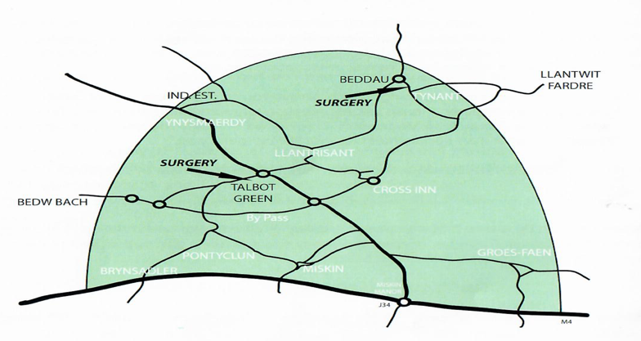  Practice Area: |  | This map shows the boundaries of our practice area.  If you live within the area and would like to join the practice, please come to the surgery and compete the necessary registration form.  If you move outside the area you will have to register with another practice

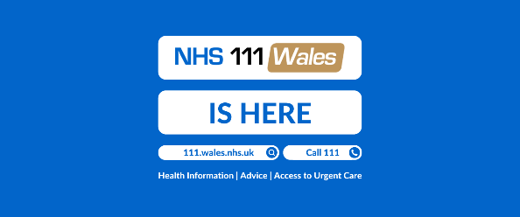

Patient Confidentiality
We respect your right to privacy and keep all your health information confidential and secure. It is important that the NHS keeps accurate and up-to-date records about your health and treatment so that those treating you can give you the best possible care.

All patient information will be treated in strict confidence. Access to all records will be limited to the people caring for the patient, including medical secretaries. Sometimes other professionals involved in patient care will need access to the notes, but this will only be done with the express permission of the doctor. We fully abide by GDPR/DPA and Caldicott Principles in the use of information.

Use of Information Act 2000
Information about patients is requested for a wide variety of purposes including education, research, monitoring, epidemiology, public health surveillance, clinical audit and planning. Only where it is essential for the purpose will identifiable records be disclosed. Such disclosure will be kept to a minimum. You have the right to object to any such disclosure and your objection will be respected.

Equality and Diversity
Talbot Green Group Practice strives to provide equality and fairness for all our patients and staff and not to discriminate on grounds of gender, gender reassignment, marital status (including civil partnerships), race, ethnic origin, colour, nationality, national origin, disability, sexual orientation, religion, or age. All patients and staff will be treated fairly and with respect. Please contact the Practice Manager if you have any concerns that Equality and Diversity issues have not been respected.

Non-NHS Services
In addition to the wide range of NHS services that are provided free at the point of delivery, we may provide other services which fall outside the scope of the NHS for which a fee is payable.

Patients’ Rights and Responsibilities
Full details on patients’ rights can be found in the Patients’ Charter leaflet, which is available to download from our website or is available from reception.

Violent or Abusive Patients
Patients should be aware that we operate a zero-tolerance policy in relation to abusive or violent behaviour. Failing to respect this policy could result in that patient and their family being removed from the practice.

Comments, suggestions and concerns
Your comments and suggestions about the practice are always welcome and these can be made through our Practice Manager, Mr John Rees. We hope you will never have cause for a serious complaint but if you do, we have a Complaints Procedure to try to resolve your problem quickly. The practice will strive to deal with complaints in a methodical and efficient manner.

You can download a copy of the full Complaints Procedure on our website or obtain one from reception. This document lays out the steps involved in making a formal complaint.

Patient participation group
The practice has an active patient group in place. We would welcome your contribution to the group. Please see website or ask at reception for further details.

Practice Premises
The practice premises have disabled access and complies with the Disability Discrimination Act.

Accessibility
Our practice leaflet is available in large print please ask at reception.

Primary Care Services
Primary Care Services, which include this practice, are the responsibility of
Cwm Taf Morgannwg Health Board, Keir Hardie University Health Park,
Aberdare Road, Merthyr Tydfil, CF48 1BZ  01685 721721

